- Write a JavaScript program to perform find the area and circumference of a circle
<!doctype html>
<html>
<head>
<script>

function funArea()
{
var rad=document.getElementById("txtRadius").value;
var area=3.14*rad*rad;
document.getElementById("txtArea").value=area;
}

function funCircum()
{
var rad=document.getElementById("txtRadius").value;
var circum=2*3.14*rad;
document.getElementById("txtCircum").value=circum;
}
</script>
</head>

<body>
<h1><b><u>Area and Circumference of a Circle</b></u></h1>

<table >
<tr>
<th align="right"> radius of the circle:</th>
<td><input type="text" id="txtRadius"></td>
</tr>
<tr>
<td align="right"><button type="button" onClick="funArea()">find area</button></td>
<td><button type="button" onClick="funCircum()">find circumference</button></td>
</tr>
<tr>
<th align="right"> Area of the circle:</th>
<td><input type="text" id="txtArea"></td>
</tr>
<tr>
<th align="right"> circumference of the circle:</th>
<td><input type="text" id="txtCircum"></td>
</tr>
</table>
</body>
</html>
- Write a JavaScript program to check whether a given number is perfect, abundant or deficient. Use alert box to display the output.
<!doctype html>
<html>
<body>
<form onSubmit="numCheck()">
enter the number: <input type="text" id="number">
<input type="submit">

</form>

<script>
function numCheck()
{
var num=document.getElementById("number").value;
var sum_fac=0;

for(var i= 1;i<=num/2;i++)
{
if(num%i==0)
{
sum_fac += i;

}
}

if(num==sum_fac)
alert(num+ " is perfect");
else if(num>sum_fac)
alert(num+ " is deficient");
else
alert(num+ " is abundant");
}

</script>
</body>
</html>
<html>
<body>
<table>
<tr>
<th id="result" colspan="2"></th>
</tr>
<tr>
<th align ="right">type of the triangle:</th>
<td id="type"></td>
</tr>
<th align ="right">area of the triangle:</th>
<td id="area"></td>
</tr>
</table>
<script >

var A = parseInt(prompt("enter the first side ", " "));
var B = parseInt(prompt("enter the second side "," "));
var C = parseInt(prompt("enter the third side "," "));

if ((A+B > C )&& (A+C > B) && (B+C > A))
{

document.getElementById("result").innerHTML="the sides " + A + ", " + B + " & "+ C + "can form a triangle";
if ((A== B) && ( B== C))
document.getElementById("type").innerHTML="equilateral";
else if ((A==B)|| (B==C) ||(A==C))
document.getElementById("type").innerHTML="isosceles";
else
document.getElementById("type").innerHTML="scalene";
var s= (A+B+C)/2;
var area=Math.sqrt(s*(s-A)*(s-B)*(s-C));
document.getElementById("area").innerHTML=area;
}
else
{
document.getElementById("result").innerHTML="the entered sides can't form a triangle";
}

</script>
</body>
</html>
- Write a JavaScript program to display the nth prime number. Value of n should be accepted from the user. Validate the value entered by the user: Only positive numbers except 0 are to be accepted.
<!doctype html>
<html>
<body>
<h1><b><u>nth prime number</u></b></h1>

Enter the value of n: <input type = "text" id ="n">
<button onClick = " validate()">ENTER</button>
<br><br>
the prime number : <input type= "text" id="prime">

<script>
function validate()
{
var num = document.getElementById("n").value;
if(num>0)
{

var count = 1;
var prime = 2;
while( count < num )
{
prime++;
for(i = 2; i <= prime ; i++)
{
if( prime % i == 0)
break;
}
if(i == prime)
count++;

}
document.getElementById("prime").value = prime;
}
else
{
alert( "please enter a valid number" );
document.getElementById("n").value = "";
}
}
</script>
</body>
</html>
- Design a JavaScript program to display the multiplication table by accepting the number and the limit.
<!doctype html>
<html>
<body>
input the number : <input type="text" id="num">
<br><br>
enter the limit : <input type="text" id="limit">
<br><br>
<button onClick = "table()">GO</button>
<p id = "disp"></p>

<script>
function table()
{
var num = document.getElementById("num").value;
var limit = document.getElementById("limit").value;
var display = " ";
for(i = 1; i <= limit; i++)
{
display += num + " * " + i + " = " + i*num + "<br>"
}
document.getElementById("disp").innerHTML = display;
}
</script>
</body>
</html>
- Design a form that accepts two integers. Provide 4 buttons for Add, Subtract, Multiply, Divide. Add JavaScript program to add, subtract, multiply and divide the given numbers when these buttons are clicked. Use output element to display the results.
<!doctype html>
<html>
<body>

<form>
Enter first number:<input type="text" id="num1">
Enter second number:<input type="text" id="num2">
=
<output id="result" ></output>
<br><br>
</form>
<button onClick="add()">ADD</button>
<button onClick="sub()">SUBTRACT</button>
<button onClick="mul()">MULTIPLY</button>
<button onClick="div()">DIVIDE</button>

<script>
function add()
{
var num1=parseInt(document.getElementById("num1").value);
var num2=parseInt(document.getElementById("num2").value);
document.getElementById("result").value=num1+num2;
}
function sub()
{
var num1=parseInt(document.getElementById("num1").value);
var num2=parseInt(document.getElementById("num2").value);
document.getElementById("result").value=num1-num2;
}
function mul()
{
var num1=parseInt(document.getElementById("num1").value);
var num2=parseInt(document.getElementById("num2").value);
document.getElementById("result").value=num1*num2;
}
function div()
{
var num1=parseInt(document.getElementById("num1").value);
var num2=parseInt(document.getElementById("num2").value);
document.getElementById("result").value=num1/num2;
}

</script>
</body>
</html>
- Write a JavaScript program to store different colors in an array and change the background color of the page using this array elements
<!doctype html>
<html>
<body>
select the color:
<select id="sel" onChange="bgcolor()">
<option value="0">white</option>
<option value="1">green</option>
<option value="2">blue</option>
<option value="3">black</option>
<option value="4">yellow</option>
<option value="5">red</option>
</select>
<script>
function bgcolor()
{
var color=["white","green","blue","black","yellow","red"];
var selected=document.getElementById("sel").value;
document.body.style.background=color[selected];
}
</script>
</body>
</html>
- Write a JavaScript program to create clock with a timing event.
<!DOCTYPE html>
<html>
<body>

<p id="demo"></p>

<script>
setInterval(clock, 1000);

function clock() {
var d = new Date();
document.getElementById("demo").innerHTML = d.toLocaleTimeString();
}
</script>

</body>
</html>
- Write a JavaScript Program to validate email based on the following condition
- Mail id must contain the @ and . character
- There must be at least one character before and after the @.
- There must be at least two characters after . (dot).
<!doctype html>
<html>
<body>
<form name="mailForm" onSubmit="formValidation()">
enter your email address:<input type="text" name="email" >
<input type="submit">
</form>
<script>
function formValidation()
{
var email=document.mailForm.email.value;
var atPos=email.indexOf("@");
var dotPos=email.indexOf(".");
if(atPos < 1 || dotPos < atPos + 2 || email.length<dotPos+3)
alert("enter a valid email address");
else
alert("successful");
}
</script>
</body>
</html>
- Write a JavaScript program for Password validation based on the following condition
- Password and confirm password must be same
- Length of password must be greater than 8 characters
<!doctype html>
<html>
<body>
<form name="pwdForm" onSubmit="formValidation()">
enter password:<input type="text" name="pwd" >
confirm password:<input type="text" name="repwd">
<input type="submit">
</form>
<script>
function formValidation()
{
var pwd=document.pwdForm.pwd.value;
var pwd1=document.pwdForm.repwd.value;
if(pwd.length<=8)
alert("enter a valid password");
else if(pwd!=pwd1)
alert("password does not match");
else
alert("successful");
}
</script>
</body>
</html>
- Write a JavaScript program to check whether a given string is palindrome or not
<!doctype html>
<html>
<body>
enter the string: <input type="text" id="in">
<button onClick="check()">ENTER</button>
<script>
function check()
{
var txt = document.getElementById("in").value;
var i = 0;
var j = txt.length - 1;
while(i<j)
{
if(txt[i]==txt[j])
{
i++;
j--;
}
else
break;
}
if(i>=j)
alert("the entered string is a pallindrome");
else
alert("the entered string is not a pallindrome");
}
</script>
</body>
</html>
- Write a JavaScript Program to create an Array and read values using Prompt popup box and display the sum of elements in an Alert Box
<!doctype html>
<html>
<body>
<script>
var len = parseInt(prompt("enter the length of the array",""));
var arr = [];
for(var i=0; i<len;i++)
{
arr[i]=parseInt(prompt("enter the elemnt",""));
}
var sum = 0;
for(i =0;i<len;i++)
{
sum+=arr[i];
}
alert("the sum of the array elemnts is "+sum);
</script>
</body>
</html>

- Change the text colour and back colour of a TextBox using onfocus and onBlur event
<!DOCTYPE html>
<html>
<body>

Enter your name: <input type="text" id="myInput" onfocus="focusFunction()" onblur="blurFunction()">

<script>
function focusFunction() {
document.getElementById("myInput").style.background = "yellow";
document.getElementById("myInput").style.color = "red";
}

function blurFunction() {
document.getElementById("myInput").style.background = "red";
document.getElementById("myInput").style.color = "black";
}
</script>

</body>
</html>
- Write a JavaScript program to display Capital of a country using onchange event. The county is selected from a select box and capital is displayed on a TextBox
<!DOCTYPE html>
<html>
<body>

Choose a country:
<select id="co" onchange="getCapital()">
<option value="">--select--</option>
<option value="New Delhi">India</option>
<option value="Colombo">Sreelanka</option>
<option value="Dhaka">Bangladesh</option>
<option value="Kathmantu">Nepal</option>
</select>
<br><br>
capital: <input type = "text" id="cap">

<script>
function getCapital()
{
var capital = document.getElementById("co").value;
document.getElementById("cap").value=capital;
}
</script>
</body>
</html>
- Write a JavaScript program to find 1st January be a Sunday between a range of years
<!doctype html>
<html>
<body>
enter the range of years:
<br><br>
From: <input type="text" id="f_year"> To: <input type="text" id="t_year">
<br><br>
<button onClick="fun()">enter</button>
<p id="op"></p>
<script>
function fun()
{
var year1 = parseInt(document.getElementById("f_year").value);
var year2 = parseInt(document.getElementById("t_year").value);
var opstring = " ";
for(var year = year1; year<=year2; year++)
{
var date = new Date(year,0,1);
if(date.getDay()==0)
opstring += "in "+ year + " 1st January is a sunday"+"<br>";
}
document.getElementById("op").innerHTML=opstring;
}
</script>
</body>
</html>

PHP

- Write a PHP program to check whether a given number is Armstrong or not.
<html>
<body>
<form method="post">
Enter the Number:
<input type="number" name="number">
<input type="submit" value="Submit">
</form>
</body>
</html>
<?php
if($_POST)
{

$number = $_POST['number'];

$a = $number;
$sum = 0;

while( $a != 0 )
{
$rem = $a % 10;
$sum = $sum + ( $rem * $rem * $rem );
$a = $a / 10;
}

if( $number == $sum )
{
echo "Yes $number an Armstrong Number";
}else
{
echo "$number is not an Armstrong Number";
}
}
?>

- Write a PHP program to check whether a given number is Armstrong or not.
<html>
<body>
<form method="post">
Enter the Limit:
<input type="number" name="limit">
<input type="submit" value="Submit">
</form>
</body>
</html>
<?php
if($_POST)
{

$limit = $_POST['limit'];

$n1 =0 ;
if($n1 <= $limit)
{
echo $n1 . "<br>";
}
$n2 = 1;
if($n2<=$limit)
{
echo $n2 . "<br>";
}
$n3 =$n1 + $n2;
while($n3 <= $limit)
{
echo $n3 . "<br>";
$n1 = $n2;
$n2 = $n3;
$n3 = $n1 + $n2;
}
}
?>
- Create a PHP program to display the bio data of a person by reading the personal details using an HTML page.

<html>

<head>

<title>

BIO DATA

</title>
</head>

<body>

<form action="bio.php" method="post">

<center> <h1> ENTER THE DETAILS</h1></center>

<table align=center>

<tr>

<td>NAME:</td>

<td><input type="text" name="name" required></td>

</tr>

<tr>

<td>CITY:</td>

<td><input type="text" name="city" required></td>

</tr>

<tr>

<td>STATE:</td>

<td><input type="text" name="state" required></td>

</tr>

<tr>

<td>PIN-CODE</td>

<td><input type="text" name="pin" required></td>

</tr>

<tr>

<td>EMAIL:</td>

<td><input type="text" name="email" required></td>

</tr>

<tr>

<td>PHONE:</td>

<td><input type="text" name="phone" required></td>

</tr>

<tr>

<td>D.O.B:</td>

<td><input type="text" name="dob" required></td>

</tr>

<tr>

<td>GENDER:</td>

<td><input type="radio" value="female" name="gender"> Female</td>

<td><input type="radio" value="male" name="gender"> Male</td>

</tr>

<tr>

<tr>

<td colspan=2><h2>EDUCATIONAL QUALIFICATION</h2></td>

</tr>

<tr>

<td>10th percentage</td>

<td><input type="text" name="ten" required></td>

</tr>

<tr>

<td>12th percentage</td>

<td><input type="text" name="twelve" required></td>

</tr>

<tr>

<td>UG percentage</td>

<td><input type="text" name="degree"></td>

</tr>

<tr>

<td>PG percentage</td>

<td><input type="text" name="mca"></td>

</tr>

<tr >

<td>EXTRA CURRICULAR ACTIVITIES:</td>

<td><input type="text" name="extra"></td>

</tr>

<tr >

<td>PROFESSIONAL QUALIFICATION:</td>

<td><input type="text" name="prf"></td>

</tr>

<tr >

<td>KNOWN LANGUAGE:</td>

<td><input type="text" name="lang" required></td>

</tr>

<tr>

<td>HOBBY:</td>

<td><input type="text" name="hobby" required></td>

</tr>

<p>

<tr><td> <input type = "submit" value="SUBMIT" ></td>

<td> <input type = "reset" value="RESET" ></td>

</tr>

</p>

</table>

</body>

</html>

Bio.php

<html>

<head>

<title>

BIO-DATA

</title>

<body>

<table border="1" width="600" align="center">

<caption align="center" style="background-color:#0FC">BIO-DATA</caption>

</table>

<table border="1" width="600" align="center" bgcolor="brown">

<tr> <font face="verdana" color="red">

<td>NAME:</td>

<td><font color="white"><?php echo $_POST['name'];?></font></td>

</font>

</tr>

<tr> <font face="verdana">

<td colspan="2" align="center" height="40" bgcolor="white"><font color="green"><b>ADDRESS</b></font></td>

</font>

</tr>

<tr>

<font face="verdana">

<td>CITY:</td>

<td><font color="white"><?php echo $_POST['city'];?></font></td>

</font>

</tr>

<tr>

<font face="verdana">

<td>STATE:</td>

<td><font color="white"><?php echo $_POST['state'];?></font></td>

</font>

</tr>

<tr>

<font face="verdana">

<td>PIN-CODE</td>

<td><font color="white"><?php echo $_POST['pin'];?></font></td>

</font>

</tr>

<tr>

<font face="verdana">

<td>EMAIL:</td>

<td><font color="white"><?php echo $_POST['email'];?></font></td>

</font>

</tr>

<tr>

<font face="verdana">

<td>PHONE:</td>

<td><font color="white"><?php echo $_POST['phone'];?></font></td>

</font>

</tr>

<tr>

<font face="verdana">

<td>D.O.B:</td>

<td><font color="white"><?php echo $_POST['dob'];?></font></td>

</font>

</tr>

<tr>

<font face="verdana">

<td>GENDER:</td>

<td><font color="white"><?php echo $_POST['gender'];?></font></td>

</font>

</tr>

<tr>

<font face="verdana">

<td colspan="2" align="center" height="40" bgcolor="white"><font color="green"><b>EDUCATIONAL QUALIFICATION</b></font></td>

</font>

</tr>

<tr>

<font face="verdana">

<td>10th</td>

<td><font color="white"><?php echo $_POST['ten'];?></font></td>

</font>

</tr>

<tr>

<font face="verdana">

<td>12th</td>

<td><font color="white"><?php echo $_POST['twelve'];?></font></td>

</font>

</tr>

<tr>

<font face="verdana">

<td>Degree</td>

<td><font color="white"><?php echo $_POST['degree'];?></font></td>

</font>

</tr>

<tr>

<font face="verdana">

<td>MCA</td>

<td><font color="white"><?php echo $_POST['mca'];?></font></td>

</font>

</tr>

<tr width="30">

<font face="verdana">

<td>EXTRA ACTIVITY:</td>

<td><font color="white"><?php echo $_POST['extra'];?></font></td>

</font>

</tr>

<tr width="30">

<font face="verdana">

<td>PROFESSIONAL QUALIFICATION:</td>

<td><font color="white"><?php echo $_POST['prf'];?></font></td>

</font>

</tr>

<tr width="30">

<font face="verdana">

<td>KNOWN LANGUAGE:</td>

<td><font color="white"><?php echo $_POST['lang'];?></font></td>

</font>

</tr>

<tr width="30">

<font face="verdana">

<td>HOBBY:</td>

<td><font color="white"><?php echo $_POST['hobby'];?></font></td>

</font>

</tr>

</table>

</body>

</html>

- Write a PHP function to reverse a string
<html>
<body>
<form method="post">
Enter the String:
<input type="text" name="str">
<input type="submit" value="Submit">
</form>
</body>
</html>
<?php
if($_POST)
{
$str = $_POST['str'];
$length = strlen($str);
for ($i=($length-1) ; $i >= 0 ; $i--)
{
echo $str[$i];
}
}
?>
- Write a PHP application to generate the pay slip of an employee by accepting name, basic salary and designation. The net salary will be calculated based on the following conditions.
Designation | Conveyance allowance | Extra allowance
Manager | 1000 | 500
Supervisor | 750 | 200
Clerk | 500 | 100
Peon | 250
HRA – 25 %
Gross= basic + HRA + conveyance allowance + extra allowance
Income tax
Gross <=2500 0%
2500 < gross <=4000 3%
4000< gross <=5000 5%
Gross >5000 8%
Net = gross – income tax

<!DOCTYPE>

<html>

<head><title> Employee Details</title></head>

<body>

<form action="payslip.php" method="post" >

<center> <h1> Employee Details</h1></center>

<br><br><br>

<table align = "center">

<tr><td> Employee Name</td>

<td> <input type = "text" name="nam"><td></tr>

<tr><td> Employee Designation</td>

<td> <select name="desig">

<option selected value="manager">Manager</option>

<option value="supervisor">Supervisor</option>

<option value="clerk">Clerk</option>

<option value="peon">Peon</option> </select>

</td></tr>

<tr><td> Basic Salary</td>

<td><input type="text" name="sal"></td></tr>

<tr></tr>

<tr><td ></td><td> <input type = "submit" value="SUBMIT" ></td></tr>

</table></form></body></html>

Payslip.php
<html>

<head><title>employee salary</title></head>

<body>

<?php

$na=$_POST["nam"];

$des=$_POST["desig"];

$basic=$_POST["sal"];

switch($des)

{

case 'manager':

$ca=1000;

$ea=500;

break;

case 'supervisor':

$ca=750;

$ea=200;

break ;

case 'clerk':

$ca=500;

$ea=100;

break;

case 'peon':

$ca=250;

$ea=0;

break;

}

$hra=0.25*$basic;

$gross=$basic+$ca+$ea+$hra;

if($gross>5000)

$it=$gross*0.08;

elseif($gross>4000)

$it=$gross*0.05;

elseif($gross>2500)

$it=$gross*0.03;

else

$it=0;

$net=$gross-$it;

echo"

<table border=1 rules=all width=50%>

<tr><td colspan=2 align=center><strong>PAY SLIP</strong></td></tr>

<tr><td width=50%>Employee Name</td>

<td width=50%>$na</td></tr>

<tr><td width=50%>Designation</td>

<td width=50%> $des</td></tr>

<tr bgcolor=eeeee>

<td>Salary Component</td><td>Amount(in Rs)</td></tr>

<tr><td>Basic Salary</td> <td>$basic</td></tr>

<tr><td>Conveyence Allowance</td> <td>$ca</td></tr>

<tr><td>Extra Allowance</td> <td>$ea</td></tr>

<tr><td>House Rent Allowance</td> <td>$hra</td></tr>

<tr bgcolor=eeeeee><td> Gross Salary</td><td>$gross</td></tr>

<tr bgcolor=eeeeee><td> Income Tax Deduction</td><td>$it</td></tr>

<tr bgcolor=eeeeee><td ><strong> Net Salary</strong></td><td><h3>$net</h3></td></tr></table>";

?>
</body>
</html>
- PHP program to store current date-time in a cookie and display the Last visited date-time on the web page upon revisiting the same web page.
<html>
<body bgcolor="87ceeb">
<center><h2> Last visited time on the web page</h2></center>
<br>
<?php

$inTwoMonths = 60 * 60 * 24 * 60 + time();
setcookie('lastVisit', date("G:i - m/d/y"), $inTwoMonths);
if(isset($_COOKIE['lastVisit']))

{
$visit = $_COOKIE['lastVisit'];
echo "Your last visit was - ". $visit;
}
else
echo "You've got some stale cookies!";
?>
</body>
</html>

- Create a table product with fields itemcode, itemname, unitprice. Write PHP program to insert 5 records into the table and display it in a table format.
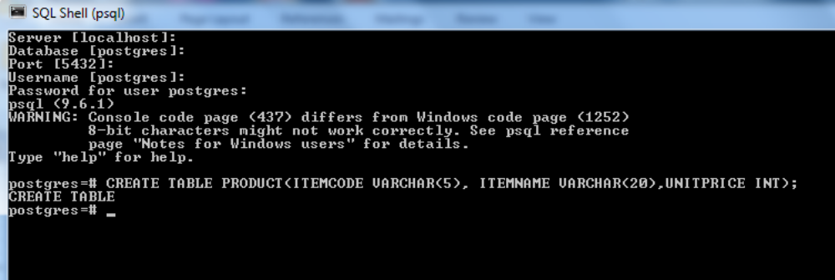

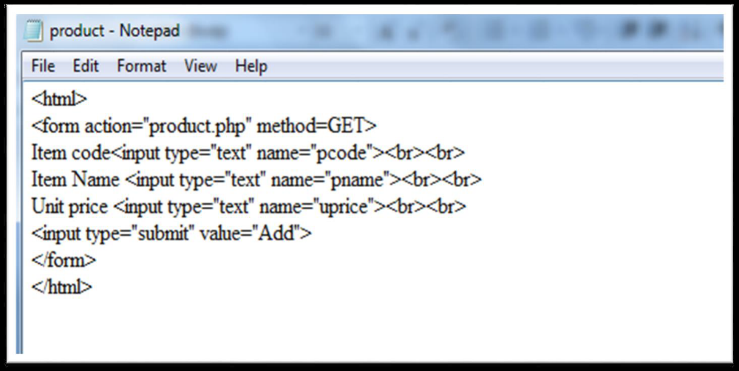

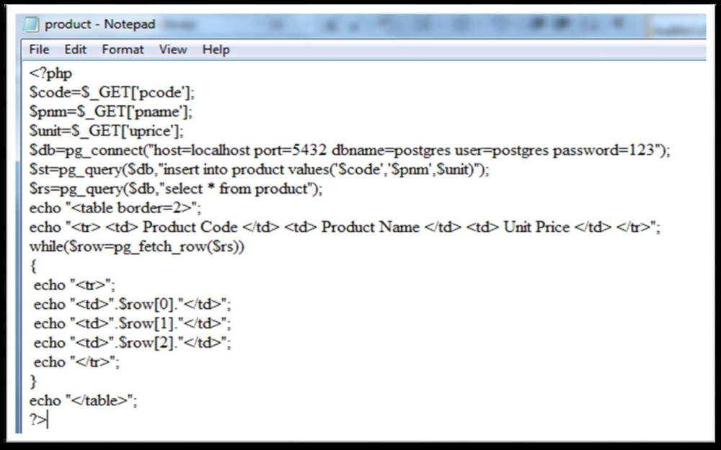

- Create a table bank with the following fields accno, cust_name, balance. Insert some Records. Design HTML page to accept Account Number and amount using TextBoxes and type of transaction (Deposit or Withdrawal) using Radio Button. Write PHP program to update balance according to the transaction

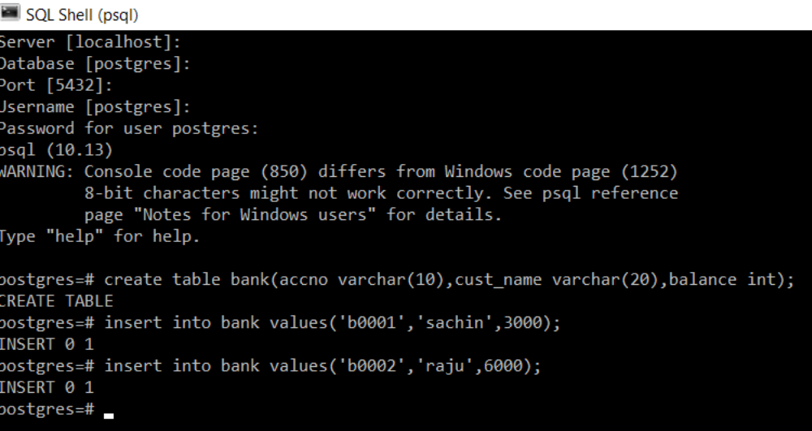

Program 26.htm
<html>
<form action = "bank.php" method = GET>
enter account number<input type="text" name="acno"><br><br>
enter amount<input type="text" name="amt"><br><br>
select transaction type <br>
<input type="radio" name="t" value="d">Deposit<br><br>
<input type="radio" name= "t" value ="w">Withdrawal<br><br>
<input type="submit" value="submit">
</form>
</html>

Bank.php

<?php
$acno = $_GET['acno'];
$amt = $_GET['amt'];
$trn = $_GET['t'];
$db = pg_connect("host=localhost port=5432 dbname=postgres user=postgres password=user");
if($trn=='d')
{
$rs = pg_query($db, "update bank set balance = balance+$amt where accno='$acno' ");
echo "amount deposited successfully ...";
$rs=pg_query($db,"select * from bank where accno='$acno' ");
echo "<table border=2>";
while($row = pg_fetch_row($rs))
{
echo "<tr><td>Account Number</td><td>".$row[0]."</td></tr>";
echo "<tr><td>Customer Name</td><td>".$row[1]."</td></tr>";
echo "<tr><td>Balance Amount</td><td>".$row[2]."</td></tr>";
}
echo "</table>";
}
if($trn=='w')
{
$rs = pg_query($db, "update bank set balance = balance-$amt where accno='$acno' ");
echo "amount withdrawed successfully ...";
$rs=pg_query($db,"select * from bank where accno='$acno' ");
echo "<table border=2>";
while($row = pg_fetch_row($rs))
{
echo "<tr><td>Account Number</td><td>".$row[0]."</td></tr>";
echo "<tr><td>Customer Name</td><td>".$row[1]."</td></tr>";
echo "<tr><td>Balance Amount</td><td>".$row[2]."</td></tr>";
}
echo "</table>";
}
?>

- Write an HTML page to display a list of fruits in a list box. Write php program to display the selected fruits in a webpage.
<html>
<head><title>Fruits Type</title>
<body>
<form action=listbox.php method = GET>
<h3> Types of Fruits, Select one </h3>
<select name=select>
<optgroup label="Simple Fruits">
<option value="Apple"> Apple</option>
<option value=Pear">Pear</option>
option value="Tomato">Tomato/option>
<option value="Peach"> Peach</option>
<option value="Cherry"> Cherry </option>
<option value="Bean">Bean</option>
<option value="Pea">Pea</option>
<option value="Coconut"> Coconut</option></optgroup>
<optgroup label="Aggregate Fruits">
<option value="Raspberry">Raspberry</option>
<option value="Blackberry">Blackberry</option>
<option value="Strawberry">Strawberry</option></optgroup>
<optgroup label="Multiple Fruits" >
<option value="Breadfruit">Breadfruit</option>
<option value="Pineapple">Pineapple</option>
<option value="Mulberry">Mulberry</option>
<option value="Jackfruit">Jackfruit
</option>
</optgroup></select>
<input type=submit name=submit value="Submit Your Choice" >
</form></body>

Listbox.php

<html>
<head>
<title>Fruits Type</title>
</head>
<body>
<?php
echo "<h3>you have selected". $_GET['select']."</h3>";
?>

</body>
</html>

- Write a PHP program to create an array and store 10 names in the array. Do the following operations.
a. Display the contents using for each statement.
b. Display the array in a sorted order.
c. Display the array without the duplicate elements
d. Remove the last element and display
e. Display the array in reverse order
f. Search an element in the given array.
<DOCTYPE html>
<html>
<head>
<title>Fruits Types</title>
<head>
<body>
<form action=array.php method=get>
<h3> select some Fruits names to create an array</h3>
<select name=fruits[] size=10 multiple required >
<option value=Apple selected> Apple</option>
<option value=Mango> Mango</option>
<option value=Banana> Banana</option>
<option value=Grapes >Grapes</option>
<option value=cherry>Cherry</option>
<option value=Bean>Bean</option>
<option value=pea> Pea</option>
<option value=coconut> Coconut</option>
<option value=raspberry>Raspberry</option>
<option value=breadfruit> Breadfruit</option>
<option value=pineapple> Pineapple</option>
<option value=mulberry> Mulberry</option>
</select>
<h3> select any operation</h3>
<select name=select >
<option value=display >Display array</option>
<option value=sort >Sort array</option>
<option value=duplicate > Remove duplicate</option>
<option value=last >REmove last element</option>
<option value=rsort>Reverse sort</option>
<option value=search >Search element</option> </select><br>
for search operation enter the value to be searched: <input type=text name="key"><br>
<input type=submit name=submit value = "Submit Your Array" >
</form>
</body>
</html>

Array.php

<!DOCTYPE html>
<html>
<head>
<title>Array Operations</title>
</head>
<body>

<?php
//create array from $_GET[fruits] array
$names=array();
$i = 0;
foreach($_GET['fruits'] as $fruit)
{
$names[$i]=$fruit;
$i++;
}
$op=$_GET['select'];

switch($op){

case 'display':
// Display array
$count=count($names);
echo "<em><strong>Your FRUITS array has $count fruits. They are:</strong</em><br>";

foreach ($names as $fruit)
echo "$fruit ";
break;

case 'sort':
//sort array
sort($names);
echo "<br><br><em><strong>Your FRUITS array in
SORTED ORDER is:</strong</em><br>";
foreach($names as $fruit)
echo "$fruit ";
break;

case 'duplicate':
//remove duplicate elements

array_unique($names);
echo "<strong> unique elements of FRUITS array are:</strong</em><br>";
foreach ($names as $fruit)
echo "$fruit " ;
break;

case 'last':
//remove last element
$last=array_pop($names);
echo "<br> <br><em> <strong> After Removing the last
element '$last' of FRUITS is:</strong></em><br>";
foreach ($names as $fruit)
echo "$fruit ";
break;

case 'rsort':
//reverse sort
rsort($names);
echo "<br><br><em><strong>Your FRUITS array in REVERSE ORDER is:</strong></em> <br>";

foreach ($names as $fruit)
echo "$fruit " ;
break;

case 'search':
$val=$_GET['key'];

if(in_array(strtolower($val),array_map('strtolower',$names))==true)

echo "item found!!";
else
echo "item not found!!";
break;
}
?>

</body>
</html>

- Display Multiplication table using PHP and AJAX
<html>
<body>
input the number : <input type="text" id="num">
<br><br>
enter the limit : <input type="text" id="limit">
<br><br>
<button onClick = "table()">GO</button>
<p id = "disp"></p>

<script>
function table()
{
var num = document.getElementById("num").value;
var limit = document.getElementById("limit").value;
var xhttp = new XMLHttpRequest();
xhttp.onreadystatechange=function(){
if(this.readyState==4 && this.status==200)
{
document.getElementById("disp").innerHTML = this.responseText;
}
};
xhttp.open("GET", "table.php?num="+num+"&limit="+limit, true);
xhttp.send();
}
</script>
</body>
</html>

Table.php
<?php
$num=$_GET['num'];
$limit=$_GET['limit'];

for($i = 1;$i <= $limit; $i++)
{
echo $num . " * " . $i . " = " . $i*$num . "<br>";
}

?>

- Write a PHP script to upload the file to the server through HTML Page

<!DOCTYPE html>
<html>
<body>

<form action="upload.php" method="post" enctype="multipart/form-data">
Select image to upload:
<input type="file" name="fileToUpload" id="fileToUpload">
<input type="submit" name="submit">
</form>

</body>
</html>

Upload.php

<?php
$target_dir = "uploads/";
$target_file = $target_dir .basename($_FILES["fileToUpload"]["name"]);
$uploadOk = 1;
$imageFileType = strtolower(pathinfo($target_file,PATHINFO_EXTENSION));
// Check if image file is a actual image or fake image
if(isset($_POST["submit"])) {
$check = getimagesize($_FILES["fileToUpload"]["tmp_name"]);
if($check !== false) {
echo "File is an image - " . $check["mime"] . ".";
$uploadOk = 1;
} else {
echo "File is not an image.";
$uploadOk = 0;
}
}
if ($uploadOk == 0) {
echo "Sorry, your file was not uploaded.";
// if everything is ok, try to upload file
} else {
if (move_uploaded_file($_FILES["fileToUpload"]["tmp_name"], $target_file)) {
echo "The file has been uploaded.";
} else {
echo "Sorry, there was an error uploading your file.";
}
}
?>

Extra notes for program 30
There is one global PHP variable called $_FILES. This variable is an associate double dimension array and keeps all the information related to uploaded file. So if the value assigned to the input's name attribute in uploading form was file, then PHP would create following five variables −
- $_FILES['file']['tmp_name'] − the uploaded file in the temporary directory on the web server.
- $_FILES['file']['name'] − the actual name of the uploaded file.
- $_FILES['file']['size'] − the size in bytes of the uploaded file.
- $_FILES['file']['type'] − the MIME type of the uploaded file.
- $_FILES['file']['error'] − the error code associated with this file upload.

The basename() function returns the filename from a path.

The pathinfo() function returns information about a file path.
pathinfo(path, options)
Possible values:
- PATHINFO_DIRNAME - return only dirname
- PATHINFO_BASENAME - return only basename
- PATHINFO_EXTENSION - return only extension
- PATHINFO_FILENAME - return only filename

